**Centre Name: ACE-HCMC-2-FPT.**

**Address: 590 Cach Mang Thang 8, District 3, Ho Chi Minh City, Viet Nam.**

**Vehicle Insurance Management**

**Design Document**

|  |  |  |
| --- | --- | --- |
| **Supervisor:** | Mr. Le Tuan Xuyen | |
| **Semester:** | 3 | |
| **Batch No:** | T1.2208.A2 | |
| **Group No:** | 2 | |
| **Order:** | **Full name** | **Roll No.** |
| 1. | **TRƯƠNG TẤN PHÁT** | **Student1409158** |
| 2. | Nguyễn Hoàng Gia Phúc | Student1408029 |
| 3. | Nguyễn Trọng Tiến Đức | Student1409132 |
| 4. | Phùng Thị Thùy Linh | Student1408057 |

* **This is to certify that**

**Mr.** Truong Tan Phat .

**Mr.** Nguyen Hoang Gia Phuc .

**Mr.** Nguyen Trong Tien Duc .

**Mr.** Phung Thi Thuy Linh .

**have successfully designed & developed:**

eProject: Vehicle Insurance Management

* **Submitted by:**

Mr. Le Tuan Xuyen

**Date of issue:** 29/11/2023

**Authorized Signature:**

# Landing page

# Login, register page

Register easily with email if you do not have an account yet. And login

# Dashboard and homepage

Login first.

In Dashboard we can check the number of subscribers, total revenue,...

And we can create insurance in Product (Insurance, Contract)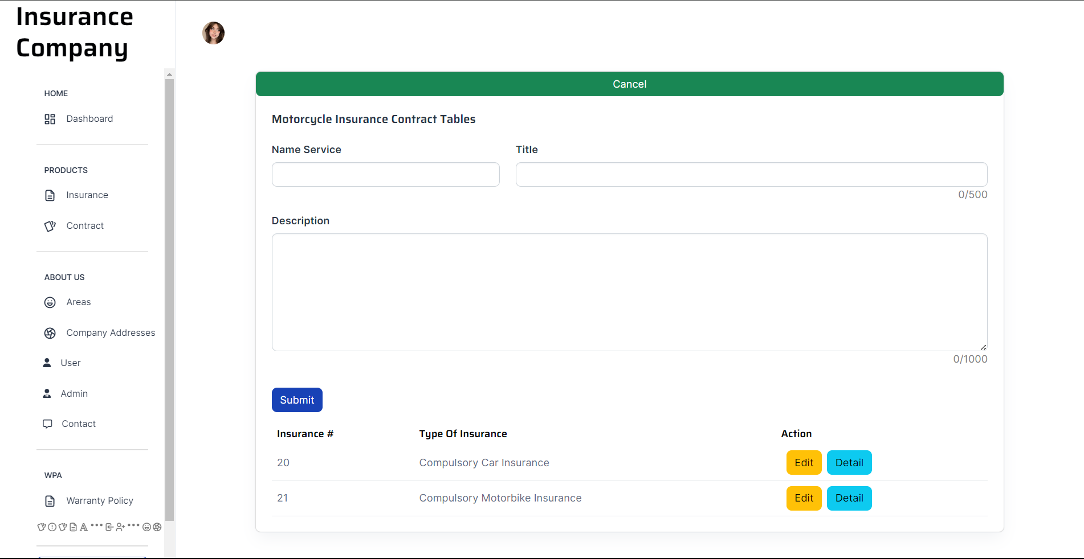

Company addresses can be created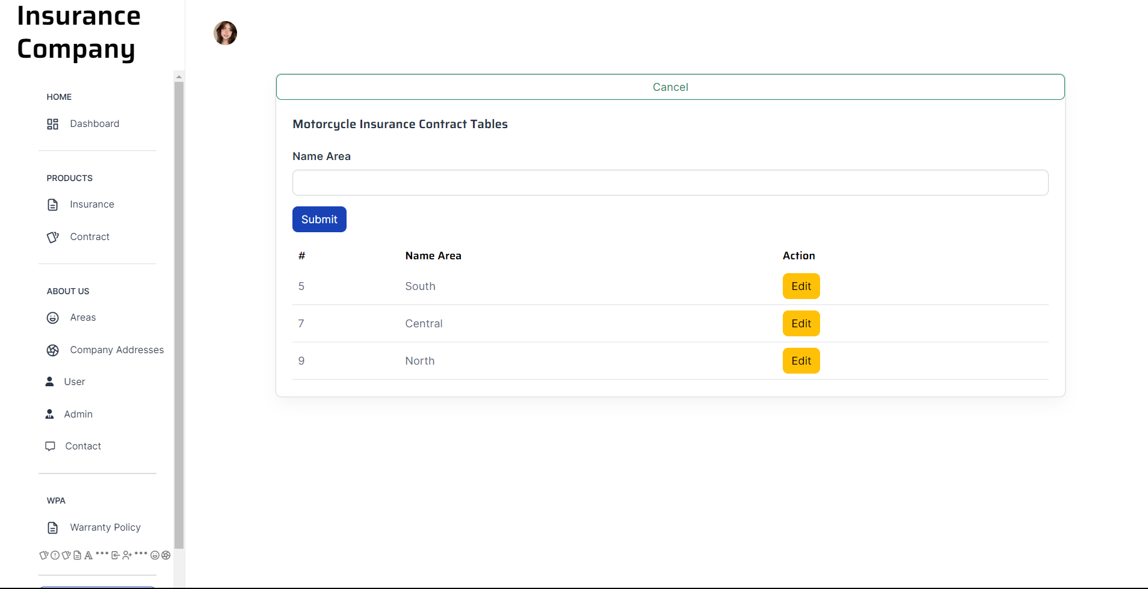

More staff

Check and respond to customers

Respond to accident claims from insurance customers

